Biometric Database Management Authority

Biometric Testing & Analysis System
(BTAS)
Request For Information

December 2018

Table of Contents

1 INTRODUCTION 3
1.1 Background 3
1.2 Classification 4
1.3 Submission date 4
1.4 Contact 4
1.5 Questions & Clarifications 4
2 BIOMETRIC TESTING & ANALYSIS SYSTEM 5
2.1 Scope 5
2.2 Out of scope 5
2.3 Biomertric methods 5
2.4 Biomertric technologies 6
2.5 Reports & Analysis 6
3 SYSTEM CONCEPT 8
3.1 Conceptual & Logical view 8
3.2 Anlysis process 10
4 ADDITIONAL REQUIREMENTS 11
4.1 General 11
4.2 Requirements 11
4.3 Required Services 11
4.4 Algorythms 12
5 SUBMISSSION METHOD 13
5.1 Introduction 13
5.2 Technical Chapter 13
5.3 Compliance Table 13
5.4 Managerial Chapter 13
5.5 Financial Chapter 14

INTRODUCTION

Background
The Biometric Database Management Authority (BDMA) of Israel is considering to establish a system for examining biometric technologies as part of its regulatory requirements.
The system is designed to enable the BDMA to examine and formulate a professional opinion on the various biometric technologies.
BDMA is interested in receiving information about organizations that are able to deliver a product and support services to perform this duty.
This is part of a general review of the issue and to prepare a list of potential suppliers/manufacturers for potential participation in an RFP.
Without this constituting an obligation on its part, BDMA invites organizations engaged in the aforementioned field and meeting the following requirements to submit information:
- An organization that is a legally registered corporation was engaged in the provision of integrative project management for the establishment of a BTAS and/or provision of technical assistance and support for BTAS system to at least one customer.
- An organization such as the aforementioned which itself delivered had performed at least one technology project that includes a BTAS.
Organizations such as the aforementioned that are interested in such are requested to submit any relevant information, including but not limited to:
- Information about the company, including a description of its experience in similar delivery.
- Exact specification of the technical specifications of the products, according to and in accordance with that stipulated in this document.
- List of similar projects in Israel and worldwide in which said products were delivered, with a focus on Biometric registry management, including details of contact people at the organizations for which equipment such as the aforementioned was installed.
Furthermore, as part of the RFI process, BDMA will request an option that the tools proposed be installed in a test environment to prove their complete operational functioning. The bidders will be requested to provide the following products and quote a price for the demo and loan:
- Loan and installation of the proposed software, including any activities required for their proper and complete activation for a period of 45 days.
- Demo and training
It is explicitly declared and emphasized that the publication of this notice is no more than the desire to receive information and does not obligate the BDMA in any matter whatsoever, including with respect to an IT system, including the manner of contractual engagement and work method.
That said, BDMA reserves the right to use the information received through this notice to compile a list of potential suppliers, as aforementioned, at its sole discretion.
It should be emphasized that should an RFP process be conducted in the future, BDMA shall be entitled to change or add conditions and requirements at its professional discretion and in accordance with its needs.
BDMA reserves the right to contact anyone who responds to this notice with a request for additional information, to supplement information and clarification, as needed and to extend the date for response as stipulated in the foregoing.

Classification
Not classified in this stage.

Submission date
All said information must be submitted by:
31/01/2019

Contact
The sole contact for clarifications, as well for submission is:
magentest@moin.gov.il

Questions & Clarifications
Questions and clarifications must be submitted before:
14/02/2019

BIOMETRIC TESTING & ANALYSIS SYSTEM
The BTAS will be used by biometric experts and is not intended to be used by end users.

Scope
The system will enable the examination of various biometric technologies, in various work descriptions, and will include the followings:
  - Comparison of different biometrics
  - Comparison of different algorithms of the same biometrics
  - Examine different versions of the same algorithm
  - Testing and quality testing of registration results in databases
  - Examinations of different effects and populations on the results of the tests
  - Tests and analysis of accuracy levels in 1: 1 and 1: N configurations and FUSION.
  - Analysis of test results according to market standards
  - Issuance of standard reports in the industry
  - Export results to Excel and other office tools.
  - Capture application for various biometrics and devices from different vendors, using standard in the industry (BioApi).

Out of scope
The system will not be designed to test:
  - Reliability, availability and maintenance;
  - Performance
  - Vulnerability
  - Data Security
  - Human factors;
  - Cost-benefit;
  - Compliance with privacy regulations.
  - Workflow Workflows.

Biomertric methods
The following biometric matching methods will be required:
- Authentication
In authentication systems, the user makes a "positive" claim to identify, requiring a "one-to-one" comparison of the sample submitted to a "biometric" sample to the record format for the given identity.
- Identification
In identification systems, the user makes or does not claim or imply a "negative" claim to be recorded, and a "one-to-many" search of the entire registered database is required. Claims claims: real & posing, positive & negative, implied
These processes are accompanied by measurement levels of verification and identification of variance such as FAR and FRR.
This document will not describe them, and can be found in the various standards documents.

Biomertric technologies
The following biometric technologies will include at least:
- Fingerprint matching
- Face recognition
- IRIS

Reports & Analysis
The analysis and reports will consist of various types which include:
- Receiver operating characteristic (ROC) curves
An accepted method for summarizing the performance of incomplete diagnostics, detection, and pattern matching systems.
The ROC curves show the function of the decision threshold between the "false identity verifications" (ie phishing attempts received) on the x-axis, versus the corresponding rate of "true identity verification"
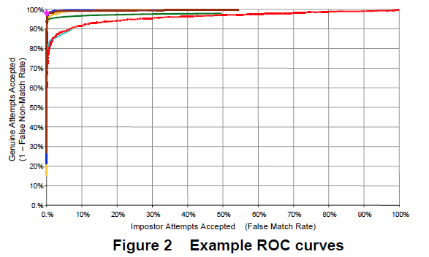
ROC curves are independent of the threshold, which allows comparing the performance of different systems under similar conditions or of one system under different conditions.

- Detection error trade-off (DET) curves:
Another ROC processing curve known as "" detection error trade-off ".
The DET curve shows the error rates on both axes, providing uniform treatment for both types of error.
DET curves can be used to adjust the corresponding error rates
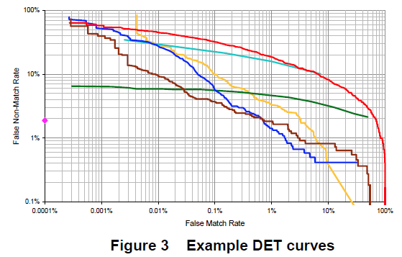

SYSTEM CONCEPT

Conceptual & Logical view
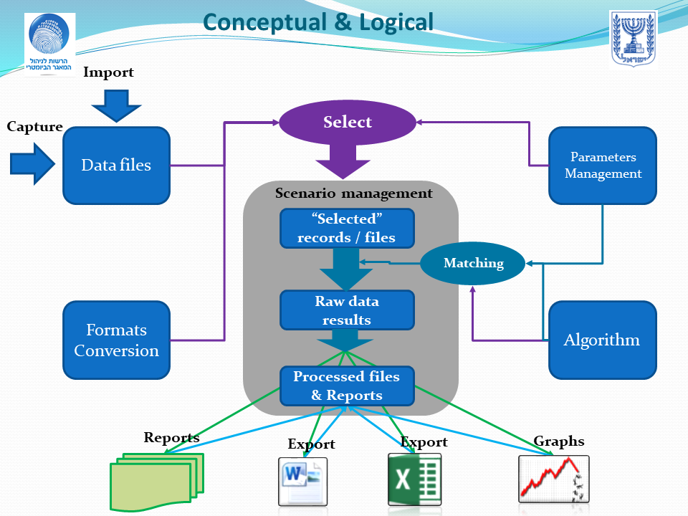

Modules description:
- Raw data files module
A module that manages biometric data files from all sources and types. The data can be of different technologies, of source images or of templates, and can come from different test files that can be purchased from research bodies, derived from real data from databases, or those that were purchased for the purpose of the tests.
Note: Deriving files from government databases will be subject to the law, and in accordance with the information security and privacy protection directives.
- B. Data conversion module
This module includes data conversion tools in various formats like ISO, FBI standards, XML structures and more.
- Parameters module
A module that allows management and maintenance of various parameters and includes levels of quality testing, different threshold levels, according to technologies and objectives, types and clusters for different select mechanisms and more.
- Matching and quality algorithms
A module that manages the various comparison mechanisms that are used for the desired tests that will be performed in the system, including versions of comparison mechanisms, suppliers and technologies, quality tests and more
- Test management
Manage workspaces where each test will be maintained with all files, parameters, results and different processing.
The environment will include:
- Selected records & files
Files after their derivation and adaptation to run certain tests, such as when biometric quality exceeds a certain parameter, or a specific population group such as men, women, age groups, etc.
- Raw data results files
Files containing the raw results of the comparisons and tests (Results can optionally be aggregated)
- Processed files & reports
A module that manages all the results and outputs of the various tests including report files and graphs generated, as well as the files exported to Excel and Word format (in order to be run again)
- Acquisition module
A module that will enable the acquisition of data in different job descriptions and different technologies.

Processes description:
- Import / Collection Process
The process of receiving a data file from an external purchased or from a designated registration to collect data tests.
- Process of preparing test files
A process that allows the selection of a data file, designated for a particular test.
The module will enable selection based on parameter and population files, conversion of formatted data into an appropriate format for testing, running and selecting a quality level required for testing.
The result of the process is a file that includes the data required for a particular test.
- The matching process
A process that performs the required matching / comparison, choosing the appropriate algorithm for the target, and determining the required parameters for testing, such as threshold required.
- Processing and reporting
A process that enables processing and comparisons based on the results of the equation, and enables production of prepared reports, graphs for processing, comparisons between different processing results, and export of data to Excel for further processing.

Anlysis process
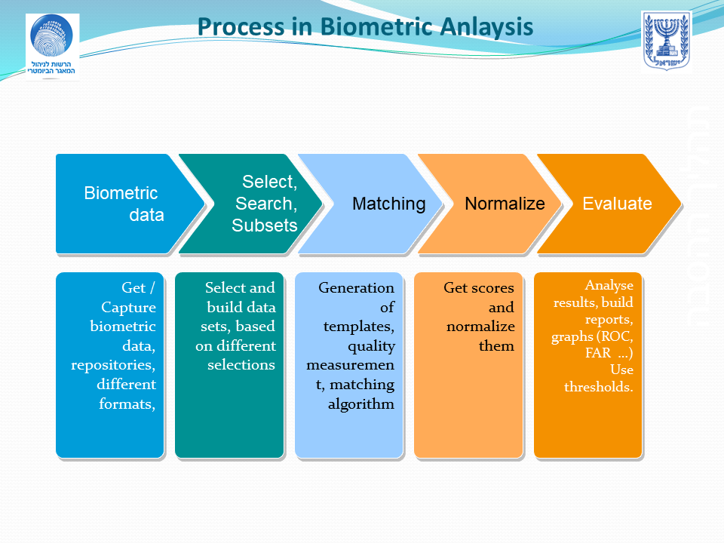

Description of the main work processes in the system:
- Collection, absorption or acquisition of biometric data files from various sources
- Selection of these files and adapting them to test needs and a specific comparison.
- Perform the required biometric comparison
- Processing of the comparison results includes normalization for comparison purposes
- Preparing reports and graphs for final results

ADDITIONAL REQUIREMENTS

General
Configuration management History and replay

Requirements
- The system will enable analysis and reporting of various types - detailed reports and graphs
- The system will allow exporting data to Excel for further processing and display
- Enabling the various processes will be implemented through Web services and external interfaces
- The system will also include FUSION types
- The licenses for the various algorithms will enable processing of limited quantities as determined
- Temporary Processing times are not critical because the system is for research purposes only.
- Flexible testing environment
- The system will enable GUI operation and / or batch files and / or command line
- Implementation of ISO / IEC 19795 performance testing & reporting
- Ensure compatibility with standard biometric data formats
- The system will allow screening test data and results based on multiple characteristics and conditions
- The system will allow the creation of templates and compare datasets to create matching scores
- The system will allow to normalize grades
- The system will work with "open" data and interface formats
- NIST XML for describing biometric data sets, images and templates
- The system shall save all historic parameters and tests scenario for regulatory purposes and enable “replay” scenaris.
- Multiple interfaces algorithm interfaces, including, BioAPI
- The system will be installed in the Windows environment
- The system shall have logging and fault and error hadling mechanis.
- Preference will be given to the establishment of a platform that is a COTS product
- The proposer shall list and present addiitinal reports and analysis

Required Services
- The system shall be installed in BDMA premises by BDMA employees and own team due to security measure
- The scope will include training ervices
- The scope shall include biometric training services
- The scope shall include Maitenance & Support ervices

Algorythms
The system shall be able to handle various algorithms.

SUBMISSSION METHOD
The proposal will be submitted according to the following outline.
The proposal will be submitted in PDF and in Powerpoint format and in Word format for the main body (Identical).

Introduction
- Submitter details and contact data.
- Executive Summary including a title and concise description of the components contained in the response, illustrative photos or figures, implementation schedule and estimated cost.

Technical Chapter
- Solution description and its implementation method.
- The technologies on which solution details are based.
- Details of performance in accordance with the details in the request body.
- Additions - a complete solution or solution components that will comply with the needs and are not detailed in this document.

Compliance Table
The submitter shall complere this table
# | Reference number to RFI | Comply / Not Comply | Reference to response clause | Remarks

Managerial Chapter
- Company profile
- Information about the company's relevant experience in the areas dealt with in this document, both in Israel and worldwide. Information about development scopes, establishment and installation of similar systems in Israel and abroad, specifying customers that use such systems, which the company has established or participated in their establishment. If the company's center of business is overseas, please specify the capabilities of the company contingent in the country, both in terms of development capabilities and support and maintenance capabilities.
- Schedule estimation for demonstration and POC of a experimental station that includes all required licenses

Financial Chapter
Price estimation structure and estimation detail will be submitted in accordance with the requirements listed below:
- Budgetery prices for licenses of the product.
- Sample cost of biometric algorithms for trials which can be attached and provide with the product (for limites quatities)
- Total cost of biometric station including all components - hardware, software, licenses and installation.
- Annual maintenance costs

